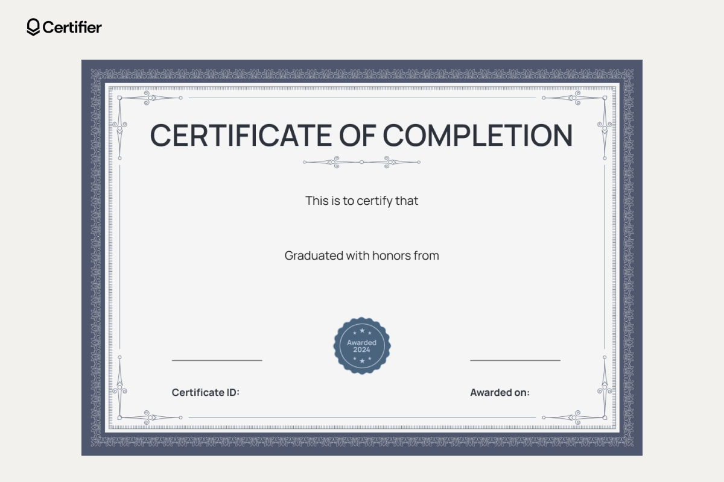
2026-09-03 00:00:00
23CSE003
Civil
Sneha Patel

